**NETHER BROUGHTON & OLD DALBY   
PARISH COUNCIL NEWS**

**Planning Determinations**

In December and January the PC received notification of the following determinations;

* **16/00585/FUL** Milestone Communications; Unit 1 Artisan Rd, Old Dalby

Single storey factory unit for the fabrication of steel mobile phone mast assemblies – **Approval of Planning Permission**

* **16/00612/TCA** Mr K Oliver; 14 Church Lane, Old Dalby

Removal of a group of trees – **Consent to work on Trees**

* **16/00346/FULHH** Mr & Mrs Annesley Williams; 15 King Street, Nether Broughton

Two storey side extension – **Approval of Planning Permission**

* **16/00622/FUL** Mr & Mrs Page; 44 Main Road, Old Dalby

Proposed replacement of dwelling and removal of trees – **Approval of Planning Permission**

* **16/00685/FULHH** Mr Barry Pratt; 34 Main Road, Old Dalby

New granny annexe to rear – **Approval of Planning Permission**

* **16/00760/TCA & 16/00759/TCA** Mrs S Beardsworth; 8 Debdale Hill, Old Dalby

Various tree work – **Consent to work on Trees**

**New Planning Applications**

In December and January the PC considered the following applications;

* **16/00775/TCA** Mr J Orson; 13 Paradise Lane, Old Dalby

Various work on trees

*This application was informative and no response was required.*

* **16/00816/FUL** Mr G C Smith Builders

Full application for the development of 4 private dwellings on land off Queensway

*Cllrs objected to the plans for the following reasons; Traffic concerns; Density; Not visually in keeping with the surrounding area; Loss of trees; Incompatibility with the pre submission Melton Local Plan.*

* **16/00836/TCA** Mr David Riley; 5 Church Lane, Old Dalby

Application for tree work

*This application was informative and no response was required.*

* **16/00911/OUT** Mr J Orson; North Lodge, Longcliffe Hill, Old Dalby

Outline application for the extension of the approved residential development to provide an additional 8 dwellings.

*Cllrs objected to the plans for the following reasons; Impact on road safety; Lack of housing need; Impact on rural landscape; Sustainability; Deviation from Housing Land Allocation.*

* **16/00762/OUT Full details not yet on website ;** Paddock Lane, Nottingham Road, Nether Broughton

The proposal seeks outline planning permission for a 6 house residential development on land on Nottingham Road, Nether Broughton

*Cllrs objected to the plans for the following reasons; Impact on road safety; Sustainability; Lack of housing need.*

Keep up to date with new planning applications and our meetings through the Parish

Council website using the following link:

<http://broughtonandolddalby.leicestershireparishcouncils.org>.

**Footpath on Longcliffe Hill**

Many of you will have noticed that a section of hedgerow was missing from the boundary of a footpath off Longcliffe Hill. This missing section ran alongside the dyke and presented a real risk to pedestrians. The PC tried to clarify who was responsible for repairs but as this was taking some time it decided to rectify this dangerous situation and has actioned repairs.

**Melton Local Plan**

The consultation period for the Melton Local Plan closed on 19th December, the PC has sent comments. MBC is now in the process of evaluating responses.

**Neighbourhood Plan**

During December and January the Advisory Committee and Theme Groups have continued to draft policies and other statements to be included in the written Neighbourhood Plan document. These reflect the very helpful feedback from residents. We are keen to obtain further comment and feedback and hence have planned open drop in sessions.

[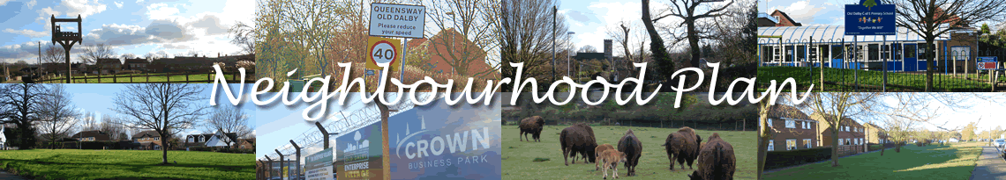](http://vocaleyes.org/uploads/7186/22bd2ee93589454e6add9a05b88a1284.png)

Drop in to comment on the draft Neighbourhood Plan for Broughton and Old Dalby Parish

Saturday 11th February 2017

* 10am – 12 noon Nether Broughton Village Hall
* 1pm – 3pm Old Dalby Village Hall
* 4pm – 6pm Queensway Scout Hut

There will be a supplementary drop in event at Old Dalby Village Hall on Saturday 25th February 10am – 12 noon

The intention is to start the formal consultation on the draft written plan in early April, thereafter the plan will be revised and submitted to Melton Borough Council in June. Subject to successful independent examination of the plan in June and July, it should be finalised and adopted by October 2017.

Lucy Flavin (Clerk to the Council) can be contacted by email at broughtondalbypc@outlook.com, or by telephoning 01664  822568.