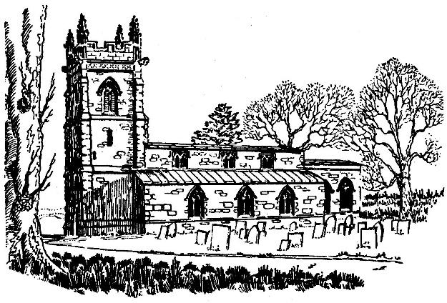

**The Church of St. Mary the Virgin,**

**Nether Broughton**

**Newsletter 29th May 2020**

**FROM THE REGISTER**

We were sorry to learn of the death on 13th May of Mr Joseph (Len) Whittaker, who grew up in Nether Broughton. We were also saddened by the sudden death of Mrs Val Anderson on 6th May, who was a good friend to many in Nether Broughton. Mrs Anderson had lived in Old Dalby for over 50 years, latterly in Hunter’s Lodge. She was regular churchgoer and a stalwart of Old Dalby Day. We extend our sincere condolences to both families at this difficult time.

**NEWS**

During the lockdown, it has not been possible for services to be held in our churches. However, despite this, our church community has continued to meet on a regular basis, using the Zoom platform. There is a service every Sunday morning at 10:00 a.m., which is always well attended by members of the congregations of St Mary’s Church and the other churches in the West Vale of Belvoir group, namely Old Dalby, Long Clawson, Hose, Harby and Stathern. In addition, there have been services of Compline on Wednesday evenings. The service of Morning Prayer includes readings, hymns and prayers, which are led by different individuals each week. The weekly reflections have been delivered by Reverend Jamie Mackay, Revd Simon Shouler or lay members of the church community.

On 26th April, Revd Jamie reflected on the journey along the road to Emmaus, where the disciples encountered the risen Christ. (*Luke Chapter 24: verses 13-35*). On 3rd May, Jo de Graaf considered the words of Jesus in St. John’s Gospel 10: verses 1-10, where Jesus likens himself to the Good Shepherd *“I came that they may have life, and have it abundantly.”* Anne Hough spoke of goodbyes, fear and trust in God on 10th May, in her reflection on John 14: verses 1-14 *“Do not let your hearts be troubled. Believe in God, believe also in me.”* This was followed, on 17th May, by Revd Jamie’s address on the work of the Holy Spirit as advocate, counsellor and bringer of abiding peace.(*John 14: verses 15-21*). On 24th May, Revd Simon Shouler took as his text the first Epistle of Peter (*I Peter 4: verses 12-14 and 5: 6-11*), in which Peter writes of gloom and despondency, such as many are feeling in these uncertain times. St Peter urges us to *“Cast all your care on the Lord, for He careth for you.”*



Revd Simon shared with us an old German woodcut, which showed the Ascension of Jesus into heaven (*Himmelfahrt* or Heavenly journey in German). Ascension Day was celebrated on Thursday 8th May by Revd Jamie, who ascended Dalby Hill to deliver the service of Morning Prayer from the top, overlooking our parishes. The reflection, from Canon Judith Wells, included the following words: It was Julian of Norwich who wrote those inspired words that *“all shall be well, and all shall be well, and all manner of things shall be well.”* Words that are poignant today as they sum up the transformation in the followers of Jesus on Ascension Day – and give *us* courage and hope in these uncertain times.

If you would like to read one or more of these reflections in full, please do ask one of us for copies.

Further services are planned for all Sundays in June and July. If you would like to participate in, or simply follow the service, please don’t hesitate to contact Revd Jamie or Martin Rhodes. You will be sent copies of the Order of Service and hymns, together with a link to join the service, which commences at 10:00 a.m. on Sunday morning. If you do not have access to a computer, you can join the service by telephone link. All are welcome!

We are told by the Bishop that churches can now be open for one designated person, the Vicar or their representative, to offer prayer for the community and beyond. Services may also be streamed from within the church by the designated person. The designated person may only be accompanied by members of their immediate family. The designated persons for our churches are: Christine Todd (Nether Broughton) and Revd Jamie Mackay (Old Dalby) [revjamiemackay@btinternet.com](mailto:revjamiemackay@btinternet.com). Please contact us if you would like us to pray for anything / person in your community. Contact details are below.

**NEW LIGHTING**

Work is soon to begin on the project to rewire and improve the lighting in the church. Hopefully, this will be completed by the time we are allowed back into the building. The new fixtures should enable us to see more clearly the fine architectural features of the building’s interior.

**THANKS**

The PCC would like to thank Mrs Janis Lee of Old Dalby for preparing and auditing the church accounts for the financial year 2018-19. We would also like to take this opportunity to thank two individuals who help to maintain St Mary’s. Mrs Sarah Hendy regularly cleans the church for us, no small task in the spring when our resident bats become active! We are also indebted to Mr P Caunt, who cuts the grass in the churchyard, so that it continues to provide a lovely, tranquil final resting place for our loved ones.

**CHURCH SECURITY**

In the early hours of the morning on Thursday 21st May, torchlights were seen in the churchyard. Having suffered three lead thefts from the St. Mary’s church in recent years, we are understandably nervous of potential criminal activity. Please could we ask that all residents, particularly those living in the vicinity of the church, are vigilant and keep a close eye on the church. Please report any suspicious activity to the police.

**COMMUNITY NEWS**

Congratulations to Mrs Freda Greaves on her birthday, who was 88 years young on 27th April. Despite that lockdown, Freda was able to celebrate the occasion with her family and friends in Nether Broughton, albeit at a safe distance from others!

Nether Broughton residents also celebrated the 75th anniversary of VE Day in style on Friday 8th May. On a beautiful, sunny afternoon, the gardens of Chapel Lane, King Street and Parnham’s Close provided a safe space for families to enjoy afternoon tea or a glass of wine alongside their neighbours. VE Day marked the end of a cataclysmic world war, that had tested the traditional fabric of so much of the country’s social existence. Following Winston Churchill’s announcement in May 1945 that the German forces had surrendered unconditionally, the country emerged onto the streets to celebrate victory.

This anniversary was a rather more subdued affair than planned, at a time when the country once again confronts a crisis; the post-war generation is facing an unexpected challenge that threatens our way of life. Nevertheless, the pandemic has forced us to reassess our priorities and reawakened a community spirit reminiscent of Britain in the Blitz. It has revealed national characteristics of self-discipline, pragmatism, generosity, compassion, decency and humour in adversity. Nowhere was this more evident than in Nether Broughton on 8th May.

**CONTACT DETAILS**

|  |  |  |  |
| --- | --- | --- | --- |
| Christine Todd (Churchwarden) | 01664 822305 | Reverend Jamie MacKay | 01664 823475 |
| Martin Rhodes | 07525 136724 | Reverend Simon Shouler | 01664 822698 |
| Inez Smith (weekends) | 01664 668631 |  |  |